**A TERM PAPER REPORT**

**ON**

**PRUS: Product Recommender System Based on**

**User Specifications and Customer Reviews**

**Submittedinthepartialfulfillmentofrequirementsto**

**CS- 363 - Term Paper**

**By**

**Batch No. 19**

**ORUGANTI MONIK PAPARAO(Y22CS139)**

**PENDYALA SKANDA BHAGAVAN (Y22CS145)**

**TULAM SAI SUDHEER (Y22CS184)**

**R.V.R.&J.C.COLLEGEOFENGINEERING(Autonomous)**

**(NAAC ‘A+’ Grade)**

**Approved by AICTE :: Affiliated to Acharya Nagarjuna University**

**Chandramoulipuram::Chowdavaram**

**GUNTUR – 522 019,Andhra Pradesh, India.**

**R.V.R & J.C. COLLEGE OF ENGINEERING(Autonomous)**

**DEPARTMENT OF COMPUTER SCIENCE AND ENGINEERING**



This is to certify that this Term Paper titled “PRUS: Product Recommender System Based on User Specificationand Customer Reviews" is the study conducted by **ORUGANTI MONIK PAPARAO (Y22CS139), PENDYALA SKANDA BHAGAVAN (Y22CS145), TULAM SAI SUDHEER (Y22CS184)** submitted in partial fulfillment of the requirements to CS 363- Term Paper during the Academic Year 2024-2025.

**Dr. S J R K Padmnivalli V Dr. S J R K Padminivalli V Dr. M. Sreelatha**

Term Paper Guide Term Paper In- Charge Prof. &Head,CSE

# ACKNOWLEDGEMENT

The successful completion of any task would be incomplete without proper suggestions, guidance and environment. Combination of these three factors acts like backbone to our Term Paper titled**“PRUS: Product Recommender System Based on User Specification and Customer Reviews”.**

We are deeply grateful to our guide, **Dr. S J R K Padminivalli V**, for her unwavering guidance, insightful feedback and encouragement. Her expertise and dedication have been instrumental in shaping the direction and quality of this research.

We would like to express our sincere gratitude to **Dr. S J R K Padminivalli V,** In-Chargefor our term paper. Her expertise, guidance and support were instrumental in the successful completion of this research.

We express our sincere thanks to **Dr.M.Sreelatha**, Head of the Department of Computer Science and Engineering for her encouragement, support, commitment to enhance research experience.

We are very much thankful to **Dr. Kolla Srinivas,** Principal, for proving this supportive environment and to engage in research activities.

Finally we submit our heartfelt thanks to lab staff in the Department of Computer Science and Engineering for their cooperation, support for providing administrative support and technical assistance during selection.

**ORUGANTI MONIK PAPARAO(Y22CS139)**

**PENDYALA SKANDA BHAGAVAN (Y22CS145)**

**TULAM SAI SUDHEER (Y22CS184)**

**ABSTRACT**

The growing popularity of online shopping has led to a continuous influx of product reviews, which play a crucial role in shaping consumer purchasing decisions. Many research studies have focused on ranking products using these reviews. However, most methodologies tend to overlook the impact of negative sentiments when evaluating products based on customer preferences. This research aims to address this gap by incorporating both positive and negative polarity in product ranking.

To achieve this, the proposed method first breaks down reviews into individual sentences, allowing for a more granular analysis of sentiment at the phrase level. By extracting key elements from these reviews, the approach effectively determines the polarity of different product features. The next step involves linking these polarities to sentence-level attributes within the review. To ensure that product rankings align with user preferences, relative importance is assigned to each polarity based on specific needs.

The effectiveness of this approach has been tested using the Amazon review dataset, where experimental evaluations were conducted using rank score (RS) and normalized discounted cumulative gain (nDCG) score. Results demonstrate that the proposed ranking system, PRUS, enables users to customize their recommended product lists by prioritizing either positive or negative aspects based on their preferences.

|  |  |  |  |
| --- | --- | --- | --- |
| **CONTENTS** | | | Page No. |
| TitlePage | | | i |
| Certificate | | | ii |
| Acknowledgement | | | iii |
| Abstract | | | iv |
| Contents | | | v |
| List of Tables | | | vi |
| List of Figures | | | vii |
| List of Abbreviations | | | viii |
| 1. | Introduction | | 1 |
|  | 1.1 | Background | 2  1  2  4  5 |
|  | 1.2 | Problem Statement |  |
|  | 1.3 | Objectives |  |
|  | 1.4 | Limitations of existing techniques |  |
| 2. | Literature Review | |  |
|  | 2.1 |  |  |
|  |  |  |  |
|  |  |  |  |
| 3. | Methodologies Used | |  |
|  | 3.1 | Architecture |  |
|  | 3.2 | Datasets to be used |  |
| 4. | Proposed Model | |  |
|  | 4.1 |  |  |
|  | 4.2 |  |  |
| 5. | Discussion on proposed output | |  |
|  | 5.1 |  |  |
|  | 5.2 |  |  |
| 6. | Conclusion | |  |
| 7. | References | |  |

## LIST OF TABLES

|  |  |  |
| --- | --- | --- |
| **Table No.** | **Table Name** | **Page No.** |
|  |  |  |
|  |  |  |
|  |  |  |
|  |  |  |

## LISTOF FIGURES

|  |  |  |
| --- | --- | --- |
| **Figure No.** | **Figure Name** | **Page No.** |
|  |  |  |
|  |  |  |
|  |  |  |
|  |  |  |

**LIST OF ABBREVIATIONS**

ABC - Artificial Bee Colony

**1. INTRODUCTION**

* 1. **Background**

The rapid expansion of the e-commerce industry has significantly transformed the way people shop. With the increasing convenience of online platforms, consumers are shifting from traditional in-store purchases to digital shopping experiences. The ability to browse a wide range of products, compare prices, read detailed descriptions, and access customer reviews from the comfort of their homes has made online shopping the preferred choice for many. The dominance of online sales has created an environment where customer feedback plays a crucial role in shaping purchasing decisions.

One of the key outcomes of the e-commerce boom is the proliferation of customer reviews on various platforms. Consumers frequently share their experiences by posting feedback on e-commerce websites (e.g., Amazon, eBay, Flipkart), social media platforms, and specialized review websites. These reviews typically highlight both the positive and negative aspects of products, offering valuable insights to potential buyers. For instance, a review of a smartphone might praise its battery life and camera quality but criticize its screen resolution. Similarly, a review of a vacuum cleaner might highlight its suction power as a positive but point out issues with its noise level or durability. These detailed reviews help potential buyers make informed purchasing decisions by offering real-world insights that go beyond product descriptions and marketing claims.



Customer reviews not only benefit potential buyers but also offer valuable data for companies. Businesses use this feedback to identify product strengths and weaknesses, improve existing products or develop new ones based on customer preferences, and enhance customer service by addressing common complaints or issues.

While customer reviews provide valuable insights, the sheer volume of online reviews makes it difficult to extract meaningful information efficiently. As e-commerce platforms grow, the number of reviews for popular products can reach into the thousands, making manual analysis impractical.

* 1. **Problem Statement**

While customer reviews provide valuable insights, they often contain **mixed sentiments** about different product features, which most existing product ranking methods fail to capture. These methods typically focus on the **overall sentiment** of reviews rather than evaluating individual aspects. For example, a review might praise a smartphone’s **camera and battery life** but criticize its **screen resolution**. Despite the negative feedback on a specific feature, the review may still be classified as positive overall, which can mislead potential buyers.

Many current ranking models **overlook feature-specific sentiments**, relying heavily on general polarity. This makes it difficult for users to identify products that align with their **specific preferences**. For instance, a phone with an excellent camera but poor battery life might be ranked higher due to its overall positive sentiment, even though a buyer prioritizing battery performance would find it unsuitable.

Furthermore, reviews often contain **contradictory opinions**, such as praising a product's **build quality** but criticizing its **customer service**. By only considering the overall sentiment, such contrasting feedback is flattened into a **single polarity**, making the review less informative.

To address this, **aspect-based sentiment analysis (ABSA)** offers a more precise approach by identifying and extracting **sentiments related to specific product features**. This allows for more **detailed and transparent product evaluations**, helping buyers filter products based on the aspects that matter most to them. By integrating ABSA, e-commerce platforms can offer **more accurate and personalized product recommendations**, enhancing the shopping experience.

* 1. **Objectives**

The primary objectives of this research are:

* **Development of the PRUS framework**: Propose a Product Recommendation based on User Specification (PRUS) framework to generate a customized product list by considering user-specified features and preferences. This framework aims to offer more tailored recommendations by addressing individual needs rather than relying on generalized rankings.
* **Multi-polarity sentiment extraction**: Implement a technique to identify and separate positive and negative sentiments within a single review, ensuring that conflicting opinions are not flattened into a single polarity. This allows the system to capture diverse opinions accurately.
* **Weighted sentiment scoring**: Introduce a technique to assign weights to both positive and negative sentiments of product features. This enables the ranking system to prioritize products based on the user's specific preferences, such as giving more importance to certain features (e.g., battery life) over others.
* **User-defined prioritization**: Allow users to define the importance of different product aspects when generating recommendations. This ensures the final ranked list reflects the user's unique needs and preferences, making the recommendations more relevant and valuable.
* **Customized product ranking**: Implement a dynamic ranking mechanism that reorders products based on the weighted sentiment scores of their aspects. This ensures that products with stronger performance in the features valued by the user are ranked higher.
* **Experimental validation**: Perform extensive evaluations using the Amazon review dataset to validate the effectiveness and accuracy of the PRUS framework. Use performance metrics such as rank score (RS) and normalized discounted cumulative gain (nDCG) to measure the precision and reliability of the system.
* **Improved decision-making**: Enhance the decision-making process for both consumers and businesses by providing more accurate, aspect-based product insights. This will help buyers make better-informed decisions and allow companies to identify product strengths and areas for improvement.
* **Scalability and adaptability**: Ensure that the PRUS framework is scalable and adaptable to different product categories and review datasets. This will make the system applicable to a wide range of e-commerce platforms.
  1. **Limitations of Existing Systems**

Despite the availability of various product ranking systems, several limitations persist in existing approaches:

* **Focus on overall sentiment**: Most existing methods primarily consider the overall sentiment of reviews, overlooking the detailed opinions on individual product features. By only capturing the general polarity of a review, these systems fail to account for feature-specific strengths and weaknesses. This can lead to inaccurate and generalized recommendations, preventing users from identifying products that align with their specific needs.
* **Lack of user-specific customization**: Many systems do not allow users to specify the importance of particular features when generating product recommendations. As a result, all product aspects are treated with equal significance, regardless of the user's priorities. For instance, a customer looking for a laptop with long battery life may receive recommendations that prioritize display quality or performance, which may not match their needs. The absence of user-driven customization reduces the relevance and effectiveness of the recommendations.
* **Inefficient sentiment extraction**: Existing models often struggle to accurately extract and link sentiments to specific product aspects. Sentiments expressed in reviews can be ambiguous or multi-faceted, making it challenging to associate the correct polarity with the appropriate feature. For example, a review mentioning, "*The phone's display is stunning, but the battery drains quickly*" contains contrasting sentiments about different aspects. However, many ranking systems fail to distinguish between them, resulting in less precise and unreliable recommendations.
* **Limited consideration of negative polarity**: Most product ranking systems prioritize positive sentiment while neglecting the significance of negative opinions. This creates a bias toward favourable reviews, leading to misleading recommendations. Negative feedback often highlights critical product flaws, such as poor durability or customer service issues, which are valuable for potential buyers. By underweighting or ignoring negative polarity, existing systems provide incomplete and overly optimistic product evaluations, making it harder for users to make informed decisions.
* **Inability to handle mixed or conflicting sentiments**: Many reviews contain conflicting opinions about different product features, but existing methods often fail to distinguish between them.
* This simplified interpretation reduces the accuracy of the recommendations, as the nuanced user experience is lost.
* **Failure to capture context-specific sentiments**: Sentiment analysis models often miss contextual nuances, such as sarcasm, irony, or subtle expressions of dissatisfaction. For instance, the sentence "*The product works... when it feels like it*" expresses negative sentiment with sarcasm, but many models misinterpret it as neutral or positive. This leads to inaccurate sentiment classification.
* **Limited adaptability across product categories**: Many existing systems are designed for specific product types, making them less adaptable to other categories. A ranking model tailored for electronics may not effectively capture the features and sentiments relevant to clothing or home appliances, limiting its applicability across diverse e-commerce platforms.
* **Static product ranking models**: Most systems generate static product rankings that do not dynamically update based on evolving user preferences or review trends. As customer opinions and product performance shift over time, static models become outdated, providing irrelevant or obsolete recommendations.
* **Lack of multi-polarity analysis**: Existing models often fail to perform multi-polarity sentiment analysis, where both positive and negative opinions within a single review are evaluated independently. For example, if a review praises a product's design but criticizes its functionality, both polarities should be considered separately. However, many systems merge conflicting sentiments, reducing the granularity and accuracy of the analysis.
* **Insufficient consideration of review credibility**: Current systems do not adequately account for fake or biased reviews, which can distort product rankings. Spam reviews or paid promotions often create misleading sentiments, making the recommendations unreliable.
* **Ineffective performance evaluation metrics**: Many existing models rely on basic evaluation metrics, which do not fully capture the effectiveness and accuracy of the ranking system. As a result, the performance of the models in real-world scenarios may not be properly measured, leading to suboptimal recommendations.
* **Reduced user satisfaction**: The inability to personalize rankings based on user preferences, coupled with the incomplete sentiment analysis, often results in irrelevant product recommendations. This reduces user trust in the system and diminishes the overall shopping experience.

**2. Literature Survey**

**2.1 Opinion-based entity ranking**

**Model Proposed by Kavita Ganesan and Cheng Xiang Zhai et. al.**

The paper focuses on developing an opinion-based entity ranking system that ranks products, businesses, and people based on user preferences and existing opinions about those entities. With the rise of Web 2.0 technologies, there has been an exponential growth in the availability of user-generated reviews and opinions. These opinions are valuable for making various decisions, such as purchasing products, booking hotels, or selecting services. However, the challenge lies in efficiently processing and leveraging the large volume of reviews to offer meaningful recommendations. The authors propose a system that directly ranks entities by how well the aggregated opinions about them match the user's preferences. Instead of merely summarizing opinions, the approach prioritizes entities based on how closely they satisfy the specified preferences, which offers more direct and effective support for decision-making tasks.

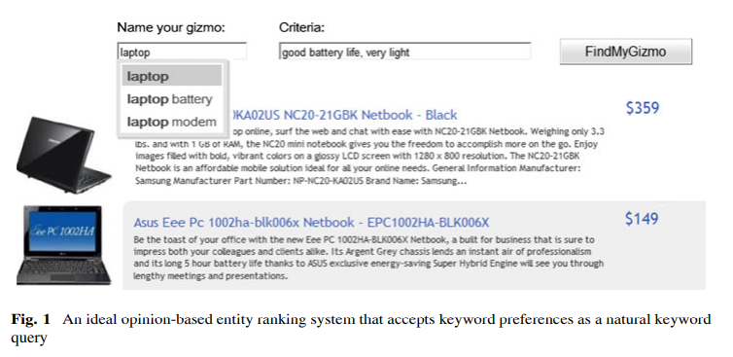

The paper introduces several retrieval models to implement this ranking mechanism. It treats all the reviews related to an entity as a single "opinion document" and ranks the entities based on how well the aggregated review content aligns with the user's query preferences. The system utilizes both standard retrieval models (such as BM25) and introduces two novel techniques: query aspect modelling (QAM) and opinion expansion. QAM segments user queries into different aspects, allowing more accurate matching with opinionated content, while opinion expansion enhances the query with additional related terms to capture a broader range of relevant opinions. Through experiments on hotel and car reviews, the authors demonstrate that these extensions significantly improve ranking accuracy. The system effectively reduces the need for users to manually sift through numerous reviews, providing a concise, preference-based ranking list, which streamlines the decision-making process.

**2.2 Aspect-based opinion ranking framework forproduct reviews using a Spearman’s rank correlation coefficient method:**

**Model Proposed by A. Kumar and S. Abirami et. al.**

Opinion mining, also known as sentiment analysis, is a field of natural language processing (NLP) that focuses on identifying and interpreting people's opinions, emotions, and sentiments expressed in textual data. It is widely used to analyse structured, semi-structured, and unstructured content from various social media platforms, e-commerce websites, and review forums. Sentiment analysis is typically performed at multiple levels:

* **Document level:** Determines the overall sentiment of an entire document (e.g., whether a review is positive, negative, or neutral).
* **Sentence level:** Identifies the sentiment of individual sentences.
* **Word level:** Examines the sentiment conveyed by specific words or phrases.
* **Aspect level:** Focuses on specific attributes or features of an entity mentioned in the text, providing more granular insights into customer preferences.

In aspect-level sentiment analysis, the system goes beyond general sentiment classification by detecting people’s likes and dislikes associated with particular product features. For instance, in a smartphone review, it can identify whether the battery life is praised but the camera quality is criticized. This makes aspect-level sentiment analysis particularly valuable for product ranking and recommendation systems, as it captures feature-specific opinions rather than an overall sentiment.

The paper introduces a new framework for ranking products based on aspect-level sentiment analysis. The process involves five key steps:

1. **Aspect Identification**:
   * The system first identifies the aspects of products by extracting relevant keywords and phrases from customer reviews.
   * For example, in laptop reviews, aspects could include battery life, display, performance, and price.
   * This step ensures that the analysis captures specific product features rather than just general sentiment.
2. **Aspect and Opinion Word Visualization**:
   * The framework uses the Harel–Koren fast multiscale layout to visualize the aspects and their associated opinion words.
   * This layout is a graph-drawing algorithm that effectively displays large-scale network data with improved readability.
   * In this case, it creates a network visualization showing the relationship between aspects and their related opinion words (e.g., "battery life" linked to "long-lasting" or "poor").
   * This visual representation helps identify positive and negative clusters of opinions associated with each aspect.
3. **Network Construction and Modelling**:
   * The system constructs a network model where products, aspects, and opinion words are interconnected.
   * The Spearman's rank correlation coefficient is applied to measure the correlation between the polarity of opinion words and product rankings.
   * Products are ranked based on the positive and negative sentiment scores derived from the reviews.
   * The Spearman’s coefficient helps in determining how closely the product ranks align with the polarity scores.
   * For example, if two products have similar positive and negative scores, they will have a high correlation, indicating they are ranked similarly.
4. **Aspect-Based Sentiment Classification:**
   * The framework uses supervised learning methods to classify the sentiment polarity of each aspect.
   * Three machine learning algorithms are applied:
     + Naïve Bayes (NB): A probabilistic classifier that uses Bayes' theorem to determine the likelihood of a sentiment being positive, negative, or neutral.
     + Maximum Entropy (ME): A model that estimates the probability distribution that best represents the data, considering all constraints. It is effective in handling imbalanced datasets.
     + Support Vector Machine (SVM): A popular machine learning algorithm that classifies data by creating a hyperplane that separates positive and negative sentiment categories.
   * These classifiers are trained on labelled data to detect and classify sentiment associated with product aspects.

**2.3 Opinion-Based Entity Ranking using learning to rank**

**S. Bashir, W. Afzal, and A. R. Baig et. al.**

The paper addresses the Opinion-Based Entity Ranking (OpER) task, which aims to rank entities based on how well the opinions about them match with user queries. With the growth of social media and e-commerce, online opinions have become a key source of information for users making purchasing or decision-making choices. However, the vast quantity of reviews makes it difficult for individuals to manually read and evaluate them. OpER offers a solution by directly ranking entities according to how closely their opinions align with user preferences. This eliminates the need for users to sift through numerous reviews, providing a more efficient and targeted recommendation process.

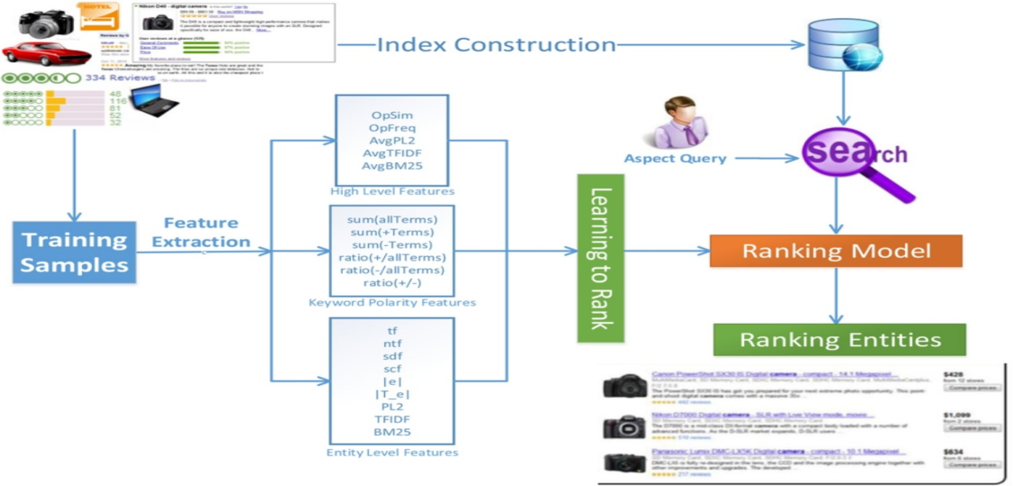

The authors introduce an extensive list of ranking features designed to capture the relevance of query keywords with individual opinions of the entities. Unlike previous approaches, which treated all opinions of an entity as a single text field, the proposed method considers the subjectivity and relevance of individual opinions to the query. This ensures that entities with positive judgments and strong relevance to the query keywords are ranked higher than those with poor relevance or negative sentiments. To further improve the effectiveness of the OpER system, the authors employ genetic programming (GP) and a learning-to-rank approach. By combining multiple ranking features, the model enhances the accuracy of the entity ranking process.

The framework is evaluated on two datasets, and the results indicate that the proposed OpER model is significantly more effective than standard retrieval models. The use of genetic programming allows the system to automatically identify and combine the most relevant ranking features, leading to better performance and more accurate recommendations. The study highlights the potential of OpER in helping users quickly find the most relevant entities without the need to read through large volumes of opinions.

**2.4 A Two-Fold Rule-Based Model for Aspect Extraction**

**Model Proposed by T. A. Rana and Y.-N. Cheah et. al.**

The paper focuses on opinion target extraction or aspect extraction, a key subtask in aspect-based sentiment analysis (ABSA). This task involves identifying the specific targets of user opinions or sentiments from online reviews, such as product features or attributes. Over recent years, syntactic pattern-based approaches have shown promising results in aspect extraction by leveraging dependency parsers to establish syntactic relations based on grammatical rules and language constraints. However, these approaches have significant limitations. Since users often express opinions informally without adhering to grammatical conventions, syntactic-based models become vulnerable to inaccuracies. Additionally, review platforms do not enforce grammatical correctness, making it harder for these methods to consistently extract aspects accurately.

To overcome these limitations, the authors propose a Two-Fold Rules-Based Model (TF-RBM) that uses sequential patterns mined from customer reviews to extract aspects. The framework consists of two phases:

1. **Domain-Independent Aspect Extraction**: The first phase extracts aspects associated with general opinion words (domain-independent), which are commonly used across multiple domains.
2. **Domain-Dependent Aspect Extraction**: The second phase focuses on aspects linked to domain-specific opinion words, capturing more specialized and context-specific features.

To further enhance accuracy, the authors apply frequency- and similarity-based approaches. These methods improve the precision and recall of aspect extraction by identifying recurring and semantically similar terms in reviews. Through experimental evaluation, the proposed TF-RBM model demonstrates better performance compared to state-of-the-art models, achieving higher accuracy and consistency in aspect extraction tasks. The results highlight the model's effectiveness in identifying product features from unstructured customer reviews, making it highly valuable for opinion mining and product ranking systems.

1. **Methodologies Used**

**3.1 Architecture**

The PRUS framework (Product Recommendation based on User Specification) is an advanced system designed to deliver personalized product recommendations by leveraging aspect-level sentiment analysis. Unlike traditional product ranking methods that rely on overall review polarity, PRUS focuses on individual product features, ensuring that the recommendations align with user-specified preferences. The framework consists of several key stages, each contributing to the accurate extraction, evaluation, and ranking of products based on their aspect-level sentiments.

The process begins with the data retrieval phase, where the system collects customer reviews from a review dataset. These reviews form the input data for the recommendation system. Instead of analyzing the reviews as a whole, PRUS breaks them down into individual sentences, allowing the system to conduct granular sentiment analysis. This segmentation is crucial because customer reviews often contain mixed opinions. For instance, a single review may praise a smartphone’s camera but criticize its battery life. By analyzing sentences individually, the framework ensures that both positive and negative sentiments associated with different features are captured separately, preventing misleading overall sentiment interpretations.

In the feature extraction phase, each sentence is processed to identify specific product features and the corresponding sentiment polarity (positive, negative, or neutral). To enhance the accuracy and relevance of the recommendations, the framework employs information gain (IG) as an evaluation method. Information gain, based on entropy calculation, measures how much predictive value a particular feature contributes to the overall classification. Features with higher information gain are deemed more informative and influential, increasing their importance in the ranking process. For example, in a laptop review, features such as battery performance or processing speed may carry more weight if they are frequently mentioned and have a significant impact on the overall user experience. This weighted evaluation ensures that the most relevant and influential product features are prioritized.

Once the features and their associated sentiments are extracted, the system appends the sentiment polarity to the respective feature. The next step is to match these extracted features with the user-specified preferences. This enables the system to prioritize products that align with the user's desired attributes.

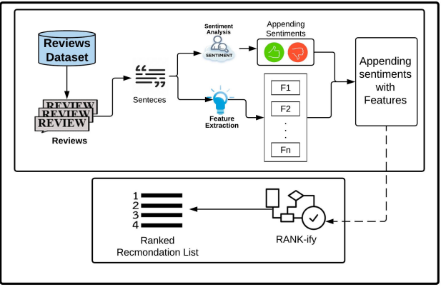

The ranking phase is executed using the **RANK-ify algorithm**, which plays a crucial role in assigning weights based on sentiment polarity. The algorithm increases the weight of features with positive sentiments, making them more influential in the final ranking. Conversely, features with negative sentiments are assigned lower weights, decreasing their influence. This weighted sentiment scoring ensures that products with more favorable feedback on the desired features appear higher in the recommendation list. By considering both positive and negative sentiments, the system offers a balanced and realistic evaluation of products, preventing bias towards only positive opinions.

Finally, the ranked recommendation list presents the products along with their features and corresponding sentiment scores, weighted according to the user’s preferences. This output provides a personalized, sentiment-driven ranking, making it easier for users to identify products that best match their specific needs. For example, a user seeking a smartphone with a good camera and long battery life would receive a list where products excelling in these areas are ranked higher, regardless of their overall review sentiment.

The PRUS framework offers several key advantages:

* **Granular sentiment analysis:** By breaking reviews into sentences, it captures feature-specific opinions instead of general sentiments.
* **Enhanced precision with information gain:** The use of information gain ensures that the most relevant and informative features carry greater influence.
* **Personalized recommendations:** The framework prioritizes products based on user-defined preferences, ensuring tailored recommendations.
* **Balanced sentiment weighting:** By applying the **RANK-ify algorithm**, the system balances positive and negative sentiments, offering fair and accurate product rankings.

**3.2 Datasets Used**

The dataset used in this study consists of 413,840 reviews, primarily collected through a data crawler from Amazon, specifically focusing on mobile phone reviews from various brands and companies. The dataset contains three key attributes:

* **Product title**: The name of the mobile phone being reviewed.
* **Brand**: The company that manufactures the mobile phone.
* **Review text**: The actual customer feedback or opinion.

**3.2.1 Data Preprocessing**

To ensure the quality and consistency of the data, a thorough preprocessing phase was conducted. During this step:

* Reviews with missing product titles or brand names were removed, as they were considered incomplete and irrelevant.
* Reviews containing fewer than five words were also eliminated, as they were unlikely to offer any meaningful feature or sentiment information.
* The remaining review text underwent cleaning and normalization processes to reduce noise and enhance the quality of the data. This included:
  + Removing stop words and punctuation to eliminate irrelevant terms.
  + Converting integers into words for consistency.
  + Stemming and lemmatizing using the WordNet Lemmatizer, which reduced words to their base or root form. This helped minimize word variations and standardize different writing styles, making the feature extraction process more effective.

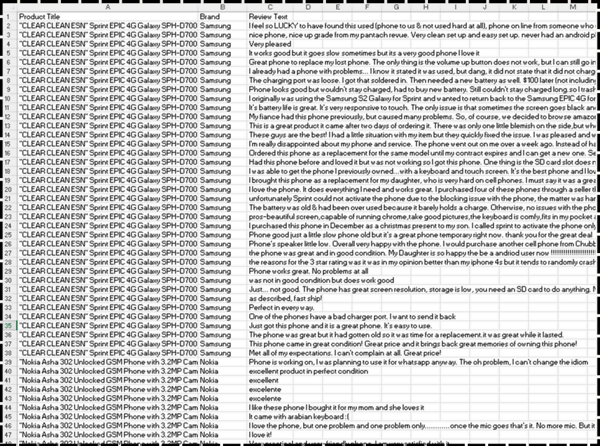

**3.2.2 Refined Dataset**

After the preprocessing phase, the dataset was refined and reduced to 316,811 reviews, which were used for the experimental evaluation of the proposed PRUS framework. The cleaning process ensured that the dataset contained high-quality, meaningful reviews by eliminating incomplete, short, or irrelevant entries. The reduced dataset offers a substantial and diverse sample for analysis, making the evaluation process more reliable and robust.

The cleaned dataset covers 371 different mobile phone brands, representing a broad spectrum of manufacturers. This diversity allows the framework to be tested across a variety of products, ensuring that the evaluation is not limited to a few popular brands. The inclusion of both major and lesser-known brands adds depth to the dataset, making the analysis more comprehensive.

Upon further examination, it was found that approximately 40% of the reviews were related to just three major brands: Samsung, BLU, and Apple. This indicates the dominance and popularity of these brands in the dataset. Their higher review volume reflects their market influence and customer base, making them significant players in the analysis. The concentration of reviews around these three brands also suggests that they attract more customer attention and engagement, possibly due to their widespread availability, brand reputation, and extensive marketing efforts.

The dataset spans reviews for approximately 4,300 different mobile phone models, showcasing a large and varied product sample. This diversity ensures that the PRUS framework is tested on a wide range of products with different specifications, performance levels, and customer experiences. Analyzing such a large number of models helps the system generalize better, making it applicable to a variety of products and not just a limited subset.

The analysis further revealed that the top ten most reviewed products in the dataset received between 800 and 1000 reviews each, indicating their popularity and high customer engagement. The large volume of reviews for these products highlights their frequent customer feedback, making them ideal candidates for detailed sentiment analysis. The presence of multiple reviews allows the PRUS framework to accurately identify trends, patterns, and recurring sentiments associated with these products. The higher review count also makes the sentiment analysis more reliable, as a larger sample size reduces the impact.

1. **Proposed Model**

The PRUS framework (Product Recommendation based on User Specification) follows a systematic process to extract aspect-level sentiments and generate a ranked product recommendation list.

* **Sentence Segmentation**

The process begins by breaking the review into individual sentences. This step is performed using the Python Natural Language Toolkit (NLTK) library, which enables efficient sentence tokenization. The purpose of this segmentation is to analyze each sentence independently, as reviews often contain mixed sentiments about different product features. By splitting the review into sentences, the system can separately evaluate each feature's sentiment, rather than relying on the overall review polarity.

* **Sentiment Analysis and Feature Extraction**

In the second phase, sentiment analysis and feature extraction are applied to the segmented sentences. This is implemented using the Python TextBlob library, which performs polarity classification by categorizing each sentence as positive, negative, or neutral. Simultaneously, TextBlob extracts the features mentioned in each sentence. For example:

* In the sentence, *"The phone has an excellent camera but poor battery life"*, the features "camera" and "battery life" are extracted.
* The sentiment polarity is positive for the camera and negative for the battery life.
  + This process is applied to all the product reviews in the dataset. Each sentence is analyzed to extract both the features and their associated sentiments, which are appended together.
* Labelling Features with Sentiment
  + Once the features and their sentiments are extracted, they are labelled accordingly:
* If a sentence expresses positive sentiment, the associated features are marked as positively reviewed.
* If a sentence has negative sentiment, its features are labelled as negatively reviewed.
* Sentences classified as neutral result in the features being labelled as neutrally reviewed.
  + This labelling enables the system to quantify the sentiment distribution for each product feature, providing a detailed sentiment breakdown.
* Sentiment Scoring
  + The system then calculates sentiment scores by counting the number of times each feature is labelled as positive, negative, or neutral across all reviews for a specific product.
* The total positive, negative, and neutral counts for each feature are aggregated.
* The sentiment score for a feature is computed using the following formula:
  + *Score = (Positive count−Negative count) / Total Count*
* This formula ensures that features with more positive occurrences receive higher scores, while those with frequent negative mentions receive lower scores.
* The neutral mentions balance the score by preventing extreme polarity shifts.
  + For instance, if the feature "camera" appears 100 times in the reviews, with 60 positive mentions, 30 negative mentions, and 10 neutral mentions, the score would be:

Score = (60-30) / 100 = 0.3

* + This indicates a moderately positive sentiment for the camera.
* **Ranking with RANK-ify Algorithm**
  + Finally, the system applies the RANK-ify algorithm to generate the ranked product recommendation list. The algorithm uses the calculated sentiment scores to rank the products:
  + Products with higher positive sentiment scores for the user-specified features are ranked higher.
  + Products with more negative mentions or lower sentiment scores are ranked lower.
  + The RANK-ify algorithm ensures that the recommendations reflect both user preferences and sentiment-based feature evaluations, providing a personalized and accurate ranking.
  + Key Benefits of the PRUS Process
  + Granular Sentiment Analysis: By analyzing sentence-level sentiments, the system captures aspect-specific opinions, preventing misleading overall polarity judgments.
  + Comprehensive Feature Scoring: The system quantifies the positivity and negativity of each feature, making the ranking more accurate and meaningful.
  + Balanced Recommendations: By considering both positive and negative sentiments, the framework provides realistic and reliable product recommendations.
  + Efficient Ranking: The use of RANK-ify ensures that the final ranked list prioritizes products with strong positive sentiments for the features specified by the user.

**4.1 Rank – ify Algorithm**

The RANK-ify algorithm is a core component of the PRUS framework, designed to rank products based on feature scores in accordance with user-specified preferences. Its goal is to generate a personalized, relevance-based product list by prioritizing products that exhibit strong positive sentiment for the features the user specifies in their query. The algorithm considers both positive and negative occurrences of the features, ensuring a balanced and realistic ranking.

**4.1.1. Input Parameters and Initialization**

The RANK-ify algorithm takes three input parameters:

* **k**: Represents the maximum number of products to be returned in descending order of relevance, i.e., from the most relevant to the least relevant according to the user's query.
* **Lp**: Refers to the set of all products in the dataset that have been reviewed. This set contains the features associated with each product along with the positive and negative occurrence counts of these features.
* **Q:** Represents the list of features extracted from the user’s query, specifying the aspects that the user prioritizes in the product search.

**4.1.2. Iterative Feature Matching**

The algorithm iterates over:

* Every feature of each product (Line 4) and
* Each feature in the user query (Line 5).

For each product, the algorithm checks if the user-specified feature exists in the list of features associated with the product (Line 6). If the queried feature is present, the algorithm proceeds to calculate the Feature Score (FeaSco) for that feature using Equation 1 (Line 7):

*FeaSco(f)=(w1*c(f+)−w2*c(f−)) / (c(f+)+c(f−))*

Where:

* c(f+) → The **count of positive occurrences** of the feature fff.
* c(f−) → The **count of negative occurrences** of the feature.
* w1 → The **weight assigned to positive occurrences**.
* w2→ The **weight assigned to negative occurrences**.
* **Condition Sum of w1 and w2 should equals to One Always!!!**

**4.1.3. Weighted Sentiment Scoring**

The weight attributes w1 and w2 control the impact of positive and negative occurrences on the final ranking. Since users may value positive and negative opinions differently, these weights allow the system to adjust the influence of each sentiment.

* For example, if the user is more concerned with positive feedback, w1 will be larger than w2.
* Conversely, if the user gives more importance to negative feedback, w2 will be larger.
* To maintain balance and prevent one sentiment from dominating the ranking excessively, the algorithm enforces the condition:

*w1+w2=1*

This ensures that the influence of both sentiment polarities is normalized.

**4.1.4. Rank-Score Calculation**

Once the FeaSco is calculated for each user-specified feature in every product, the algorithm sums these feature scores to compute the overall Rank-Score of the product (Line 10). This Rank-Score represents the combined sentiment impact of all features in relation to the user’s query.

* Products with higher Rank-Scores exhibit stronger positive alignment with the user’s preferences.
* Products with more negative sentiment or fewer matching features receive lower scores.

**5. Sorting and Final Recommendation**

After calculating the Rank-Score for all products, the algorithm sorts the products in descending order (Line 12), prioritizing those with higher Rank-Scores.

* The top-k products from the sorted list are returned to the user (Line 13), providing a personalized and ranked recommendation list that closely matches their preferences.

Example Execution

For example, if a user queries for a smartphone with good battery life and camera, the algorithm:

* Iterates through all products and checks if they contain these features.
* Calculates the FeaSco for both battery life and camera by considering the positive and negative occurrences.
* Combines the FeaSco values into an overall Rank-Score for each product.
* Sorts the products based on their Rank-Score and presents the top-k ranked products to the user.

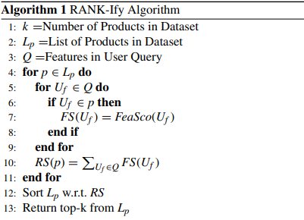

**Key Benefits of the RANK-ify Algorithm**

* **Granular Sentiment Evaluation:** By considering both positive and negative occurrences, the algorithm offers a balanced ranking.
* **Weighted Scoring:** The weight parameters allow the system to customize the impact of positive and negative feedback, aligning with user priorities.
* **Efficient and Scalable:** The algorithm efficiently processes large datasets by iterating over relevant features only, making it suitable for scalable e-commerce platforms.
* **Personalized Recommendations:** By prioritizing products based on user-specified features, the algorithm generates accurate and personalized recommendations, enhancing the user experience.

Overall, the **RANK-ify algorithm** is a robust and efficient method for ranking products based on aspect-level sentiment analysis. Its ability to consider both positive and negative occurrences, apply weight-based scoring, and provide personalized recommendations makes it highly effective for e-commerce product ranking systems.

1. **Discussions on the Proposed Output**

**5.1 Experiments and Results**

The experimental evaluation of the PRUS framework demonstrates its effectiveness in generating personalized product recommendations by ranking products based on aspect-level sentiment analysis. The evaluation was conducted using a preprocessed Amazon dataset containing mobile phone reviews from various brands. The system was tested by extracting features from a user query and generating a ranked recommendation list based on the Discounted Cumulative Gain (DCG) measure. The results highlight the accuracy and reliability of the PRUS framework in providing feature-specific recommendations, overcoming the limitations of overall review-based scoring.

**Sentiment-Driven Feature Scoring**

In the proposed approach, TextBlob was used to perform sentiment analysis, assigning individual sentiment scores to the features of each product. These scores were normalized on a scale of 1 to 10 to ensure consistent evaluation across all products. The framework calculates the Average Aspect Score (AAS) for each product using thebelow equation:



Here, for a product p, all the features relevant to the user query (Q) are considered. Their sentiment scores are averaged, providing a composite score that reflects the product’s overall feature relevance. This ensures that products are ranked based on the sentiment scores of the features that matter most to the user, rather than relying on an overall rating.

For example, in a review stating:

*“The screen quality is good, but the battery life is poor,”*

The **screen quality** receives a **sentiment score of 8.65**, while the **battery life is assigned score of 3.7**, indicating positive and negative sentiments for different features. Traditional systems would assign a single overall rating, which could be misleading, while PRUS assigns individual scores to each feature, offering more precise and granular sentiment analysis.

**DCG and nDCG-Based Ranking**

Once the AAS values are calculated for all products, the DCG score is computed using the below Equation:



The DCG score quantifies how effectively a product matches the user-specified features and their associated sentiment scores. To ensure a fair and unbiased ranking, the system calculates the Ideal DCG (IDCG) using the below Equation:



The IDCG represents the optimal ranking scenario, where the most relevant products receive the highest scores. Finally, nDCG is calculated using the below Equation:

​ 

The nDCG value ensures that the ranking is normalized, making it more consistent and reliable across different product lists.

**Demonstration of the Output**

To demonstrate the effectiveness of PRUS, the authors conducted an example evaluation using a user query that requested a mobile phone with a good camera and high screen resolution. The system successfully displayed the top 10 ranked products based on:

* Rank Score (RS): Calculated using the RANK-ify algorithm.
* nDCG values: Derived using Equation 5.

The results showed that the highest-ranked products were those that received strong positive sentiment scores for both camera quality and screen resolution. While several products shared the same Rank Score (0.9), the nDCG values varied, allowing the system to further differentiate the products based on their overall sentiment relevance.

* The products with higher nDCG scores appeared at the top of the recommendation list, as they exhibited stronger positive feedback for the features specified by the user.
* The products with lower nDCG scores were ranked lower, reflecting their weaker alignment with the user’s query.
* This two-layer ranking system ensures that the most relevant products are placed higher, even when multiple products have the same Rank Score.

**Key Advantages of the PRUS Output**

The experimental results demonstrate several key benefits of the PRUS framework:

* Feature-Specific Ranking: Unlike traditional models that rely on overall ratings, PRUS assigns individual sentiment scores to product features, ensuring more accurate and personalized recommendations.
* Granular Sentiment Analysis: The system successfully captures both positive and negative opinions about different product features, preventing misleading overall ratings.
* DCG-Based Normalization: The use of nDCG values ensures that products are ranked fairly and consistently, even when their Rank Scores are identical.
* Improved Decision-Making: The feature-based scoring allows users to make better-informed decisions by clearly identifying products that excel in the specific features they care about.
* Efficient Query-Based Personalization: PRUS effectively tailors the recommendations to user preferences, offering a highly customized product ranking.

Discussion on Practical Implications

The PRUS framework offers a significant improvement over traditional product ranking methods, especially for e-commerce platforms. The ability to prioritize features based on user-specified preferences ensures that the recommendations are:

* Highly relevant and tailored to individual needs.
* Accurate, as the system captures fine-grained feature sentiments rather than relying on general product ratings.
* Efficient, by applying DCG and nDCG scoring, making the ranking fair and consistent across products.

For example, a customer searching for a laptop with long battery life and lightweight design would benefit from PRUS, as it ranks products based on aspect-specific sentiment scores rather than general ratings.

Overall, the experimental output of the PRUS framework demonstrates its effectiveness, reliability, and practicality in delivering accurate, feature-specific, and personalized product recommendations.

**5.2 Performance Analysis of the PRUS Method**

The **PRUS framework** was subjected to a series of experiments to evaluate its performance and effectiveness in generating ranked product recommendations based on user-specified features. The experiments were conducted by varying the weights w1w1w1 and w2w2w2, which control the influence of positive and negative occurrences of product features, respectively. The key objective was to observe the impact of these weight variations on the Rank Score (RS) and Normalized Discounted Cumulative Gain (nDCG), which are used as evaluation metrics.

**5.2.1. Experiment Setup and Weight Variations**

In the experiments, the **weights were alternated** in such a way that their **sum equals 1**, i.e.,w1+w2=1

The weights were varied over a range of **0.1 to 0.9**, creating different **combinations of positive and negative influence** on the final product ranking. The **product list (P1 to P10)** represents the **top-ranked products** based on the **RS and nDCG scores** corresponding to the different weight combinations. The **results of these experiments** are summarized in the below Table**.**

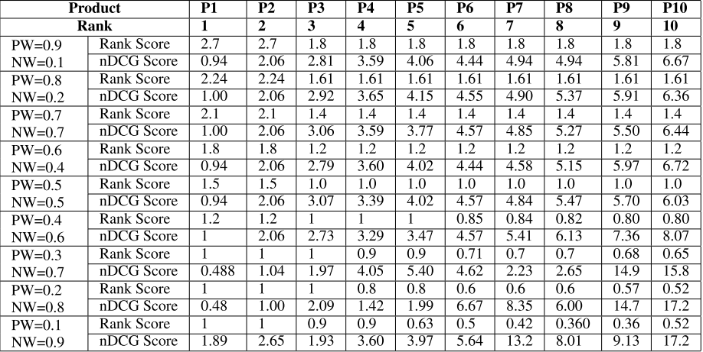

**5.2.2. Impact of Positive and Negative Weights on nDCG**

The nDCG scores represent the relevance of the ranked products based on the user-specified features and their associated sentiments. The experimental results reveal the following trends:

* When the positive weight (w1) ranges between 0.9 and 0.5, there is no significant change in the overall nDCG scores. This indicates that as long as positive sentiments dominate, the relevance of the product ranking remains consistent.
* However, as soon as the negative weight (w2) increases beyond 0.5, there is a sudden increase in the nDCG scores. This happens because products with more negative mentions gain higher weight, making them more prominent in the ranking.
* This outcome demonstrates that nDCG scores increase when negative feedback is given more importance, reflecting a shift in product relevance towards products with more critical sentiments.

**5.2.3. Impact on Rank Score (RS)**

The **Rank Score (RS)**, calculated using the **RANK-ify algorithm**, represents the overall product ranking based on both positive and negative occurrences of the features. The experimental results show the following trend:

* When the positive weight (w1) is high (greater than 0.5), products with more positive feature sentiments receive higher Rank Scores.
* As the negative weight (w2) crosses 0.5, the RS begins to decline. This is because the increased influence of negative feedback causes products with more negative mentions to be ranked higher, lowering the RS for products with predominantly positive reviews.
* This behaviour aligns with the FeaSco formula (Equation 1), which defines the Feature Score as:

*FeaSco(f)=(w1*c(f+)−w2*c(f−)) / (c(f+)+c(f−))*

Where:

* w1 → The positive weight.
* w2 → The negative weight.
* c(f+) → The count of positive occurrences.
* c(f−) → The count of negative occurrences.
* Increasing w2 reduces the overall FeaSco value, leading to lower Rank Scores for products with more positive mentions.

**5.2.4. Influence of Weight Variation on the Product List**

The product list (P1 to P10) varies significantly as the positive and negative weights are adjusted.

* With higher positive weights, the products with strong positive sentiment for the user-specified features dominate the top ranks.
* As the negative weight increases, the list becomes populated with products that have more negative mentions for the specified features, reflecting the increased influence of negative sentiment.
* This highlights the flexibility of the PRUS framework, allowing users to adjust the ranking by controlling the impact of positive and negative occurrences.

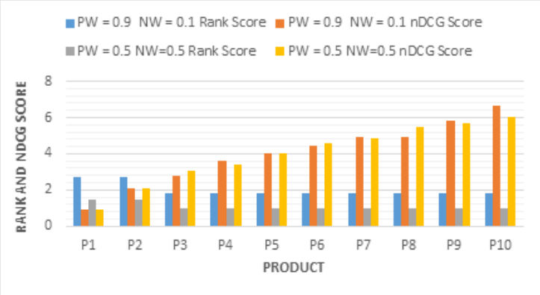

**5.2.5**. **Key Observations from the Performance Analysis**

The experiments reveal several key insights into the performance of the PRUS framework that was discussed in the paper:

* No Major Change in nDCG with Higher Positive Weight: When the positive weight ranges between 0.9 and 0.5, there is no substantial change in the nDCG scores. This suggests that as long as positive sentiment dominates, the overall relevance of the recommendations remains stable.
* nDCG Increases with Higher Negative Weight: As the negative weight increases beyond 0.5, nDCG scores rise sharply. This is because the system prioritizes products with more negative feedback, making critical reviews more prominent in the ranking.
* Rank Scores Decrease with Increasing Negative Weight: When negative sentiment gains more influence (w2 > 0.5), the Rank Scores decline. This occurs because negative features are weighted more heavily, reducing the overall RS of products with predominantly positive reviews.
* User-Controlled Sentiment Influence: The PRUS framework provides users with the ability to control the degree of positive and negative influence on the final product list. This makes the system highly flexible and customizable, catering to individual preferences.

1. **Conclusion and Future Work**

**6.1. Conclusion**

In this study, a Product Recommendation based on User Specification (PRUS) framework was proposed to generate a personalized, ranked list of products by analyzing customer reviews. Unlike existing methods, the PRUS approach incorporates both positive and negative sentiments of individual product features, enabling more accurate and personalized recommendations. While traditional ranking models often prioritize products based on overall sentiment, PRUS addresses the granularity issue by performing aspect-level sentiment analysis, ensuring that feature-specific opinions influence the ranking process.

The PRUS framework operates in three phases:

1. **Feature and Sentiment Extraction**: The system extracts features and their associated sentiments from individual sentences of customer reviews, capturing both positive and negative opinions at the sentence level.
2. **Feature-Sentiment Association**: The extracted features are appended with their respective sentiment polarities, allowing the system to quantify the positive and negative occurrences of each feature.
3. **Ranking Phase**: The user-specified features are extracted from the query, and the products are ranked using the RANK-ify algorithm based on their Rank Scores (RS). The RS considers both positive and negative weights, providing a balanced and realistic ranking.

The PRUS framework offers flexibility by allowing users to adjust the weight parameters associated with positive and negative sentiments. This gives users the ability to customize the ranking based on their individual preferences. Through extensive experiments, the PRUS framework demonstrated its effectiveness and accuracy in generating personalized recommendations, showing that:

* Increasing the negative weight results in a higher nDCG score, as products with more negative mentions become more prominent in the ranking.
* Increasing the positive weight causes the Rank Score to increase, prioritizing products with more positive sentiment.

The experimental results validated the reliability and accuracy of the PRUS framework, making it a robust solution for e-commerce platforms and other review-based product ranking systems.

**6.2. Future Work**

While the PRUS framework has demonstrated promising results, several avenues for future research remain open. These directions aim to enhance the framework’s flexibility, scalability, and applicability in real-world scenarios:

1. **Multilingual Product Review Datasets**:
   * The current PRUS framework is applied to English-language reviews only. A natural extension of this work would be to implement multilingual support.
   * This would enable the framework to process reviews in multiple languages, making it applicable to global e-commerce platforms.
   * Future work could incorporate language translation models or multilingual sentiment analysis techniques to extract feature-level sentiments across diverse languages.
2. **User-Controlled Polarity Customization**:
   * The PRUS framework currently allows users to adjust the weight parameters associated with positive and negative sentiments, offering some flexibility in ranking.
   * Future enhancements could provide more advanced customization options, allowing users to:
     + Specify individual sentiment thresholds for specific features.
     + Define custom polarity preferences, such as favoring features with balanced sentiments or discounting neutral feedback.
   * This would result in more dynamic and user-centric recommendations.
3. **Incorporating Contextual and Temporal Factors**:
   * Future research could enhance the PRUS framework by incorporating contextual information such as time-sensitive reviews or trending sentiments.
   * This would allow the system to prioritize recent reviews or consider seasonal trends when ranking products, making the recommendations more relevant and timely.
4. **Real-Time Product Recommendation System**:
   * To make the PRUS framework more practical for real-world applications, future work could focus on real-time product ranking.
   * This would enable the system to dynamically rank products as new reviews are added, ensuring that the recommendations remain current and accurate.

**References**

[1] P. K. Jain, R. Pamula, and G. Srivastava, ‘‘A systematic literature review on machine learning applications for consumer sentiment analysis using online reviews,’’ Comput. Sci. Rev., vol. 41, Aug. 2021, Art. no. 100413.

[2] S. Moro and P. Rita, ‘‘Data and text mining from online reviews: An automatic literature analysis,’’ WIREs Data Mining Knowl. Discovery, vol. 12, no. 3, May 2022, Art. no. e1448. [3] N. Hussain, H. T. Mirza, G. Rasool, I. Hussain, and M. Kaleem, ‘‘Spam review detection techniques: A systematic literature review,’’ Appl. Sci., vol. 9, no. 5, p. 987, Mar. 2019.

[4] L. He, X. Wang, H. Chen, and G. Xu, ‘‘Online spam review detection: A survey of literature,’’ Hum.-Centric Intell. Syst., vol. 2, nos. 1–2, pp. 14–30, Jun. 2022.

[5] S. K. Maurya, D. Singh, and A. K. Maurya, ‘‘Deceptive opinion spam detection approaches: A literature survey,’’ Int. J. Speech Technol., vol. 53, no. 2, pp. 2189–2234, Jan. 2023.

[6] E. Lee, F. Rustam, P. B. Washington, F. E. Barakaz, W. Aljedaani, and I. Ashraf, ‘‘Racism detection by analyzing differential opinions through sentiment analysis of tweets using stacked ensemble GCR-NN model,’’ IEEE Access, vol. 10, pp. 9717–9728, 2022.

[7] W. S. El-Kassas, C. R. Salama, A. A. Rafea, and H. K. Mohamed, ‘‘Automatic text summarization: A comprehensive survey,’’ Expert Syst. Appl., vol. 165, Mar. 2021, Art. no. 113679.

[8] M. Umer, I. Ashraf, A. Mehmood, S. Kumari, S. Ullah, and G. S. Choi, ‘‘Sentiment analysis of tweets using a unified convolutional neural network-long short-term memory network model,’’ Comput. Intell., vol. 37, no. 1, pp. 409–434, Feb. 2021.

[9] P. K. Soni and R. Rambola, ‘‘A survey on implicit aspect detection for sentiment analysis: Terminology, issues, and scope,’’ IEEE Access, vol. 10, pp. 63932–63957, 2022. [10] N. Aslam, K. Xia, F. Rustam, A. Hameed, and I. Ashraf, ‘‘Using aspectlevel sentiments for calling app recommendation with hybrid deep-learning models,’’ Appl. Sci., vol. 12, no. 17, p. 8522, Aug. 2022.

[11] G. Brauwers and F. Frasincar, ‘‘A survey on aspect-based sentiment classification,’’ ACM Comput. Surv., vol. 55, no. 4, pp. 1–37, Apr. 2023.

[12] M. Sivakumar and S. R. Uyyala, ‘‘Aspect-based sentiment analysis of mobile phone reviews using LSTM and fuzzy logic,’’ Int. J. Data Sci. Anal., vol. 12, no. 4, pp. 355–367, Oct. 2021.

[13] J. Zhang, X. Lu, and D. Liu, ‘‘Deriving customer preferences for hotels based on aspect-level sentiment analysis of online reviews,’’ Electron. Commerce Res. Appl., vol. 49, Sep. 2021, Art. no. 101094.

[14] K. Ganesan and C. Zhai, ‘‘Opinion-based entity ranking,’’ Inf. Retr., vol. 15, no. 2, pp. 116–150, Apr. 2012.

[15] L. Akoglu, ‘‘Opinion fraud detection in online reviews by network effects,’’ in Proc. ICWSM, vol. 7, no. 1, 2013, pp. 2–11.

[16] E. Marrese-Taylor, J. D. Velásquez, and F. Bravo-Marquez, ‘‘A novel deterministic approach for aspect-based opinion mining in tourism products reviews,’’ Expert Syst. Appl., vol. 41, no. 17, pp. 7764–7775, Dec. 2014.

[17] A. Kumar and S. Abirami, ‘‘Aspect-based opinion ranking framework for product reviews using a Spearman’s rank correlation coefficient method,’’ Inf. Sci., vols. 460–461, pp. 23–41, Sep. 2018.

[18] S. Bashir, W. Afzal, and A. R. Baig, ‘‘Opinion-based entity ranking using learning to rank,’’ Appl. Soft Comput., vol. 38, pp. 151–163, Jan. 2016.

[19] T. A. Rana and Y.-N. Cheah, ‘‘A two-fold rule-based model for aspect extraction,’’ Expert Syst. Appl., vol. 89, pp. 273–285, Dec. 2017.

[20] C. Wu, F. Wu, S. Wu, Z. Yuan, and Y. Huang, ‘‘A hybrid unsupervised method for aspect term and opinion target extraction,’’ Knowl.-Based Syst., vol. 148, pp. 66–73, May 2018.

[21] Z. Luo, S. Huang, F. F. Xu, B. Y. Lin, H. Shi, and K. Zhu, ‘‘ExtRA: Extracting prominent review aspects from customer feedback,’’ in Proc. Conf. Empirical Methods Natural Lang. Process., 2018, pp. 3477–3486.

[22] S. Sharmila and S. Vijayarani, ‘‘Association rule mining using fuzzy logic and whale optimization algorithm,’’ Soft Comput., vol. 25, no. 2, pp. 1431–1446, Jan. 2021.

[23] S. Gurumoorthy, B. N. K. Rao, X.-Z. Gao, B. V. Krishna, A. K. Pandey, and A. S. Kumar, ‘‘Feature based opinion mining and sentiment analysis using fuzzy logic,’’ in Cognitive Science and Artificial Intelligence (SpringerBriefs in Forensic and Medical Bioinformatics). Singapore, 2018, pp. 79–89.

[24] M. Venugopalan and D. Gupta, ‘‘An enhanced guided LDA model augmented with BERT based semantic strength for aspect term extraction in sentiment analysis,’’ Knowl.-Based Syst., vol. 246, Jun. 2022, Art. no. 108668.

[25] M. Hu and B. Liu, ‘‘Mining and summarizing customer reviews,’’ in Proc. 10th ACM SIGKDD Int. Conf. Knowl. Discovery Data Mining, Aug. 2004, pp. 168–177.

[26] A.-M. Popescu and O. Etzioni, ‘‘Extracting product features and opinions from reviews,’’ in Proc. Conf. Hum. Lang. Technol. Empirical Methods Natural Lang. Process. (HLT), 2005, pp. 9–28.

[27] S. Li, L. Zhou, and Y. Li, ‘‘Improving aspect extraction by augmenting a frequency-based method with web-based similarity measures,’’ Inf. Process. Manage., vol. 51, no. 1, pp. 58–67, Jan. 2015.

[28] Z. Li, M. Zhang, S. Ma, B. Zhou, and Y. Sun, ‘‘Automatic extraction for product feature words from comments on the web,’’ in Proc. Asia Inf. Retr. Symp. Sapporo, Japan: Springer, Oct. 2009, pp. 112–123.

[29] S. Raju, P. Pingali, and V. Varma, ‘‘An unsupervised approach to product attribute extraction,’’ in Proc. Eur. Conf. Inf. Retr. Toulouse, France: Springer, Apr. 2009, pp. 796–800.

[30] Ö. F. Güneş, T. Furche, and G. Orsi, ‘‘Structured aspect extraction,’’ in Proc. COLING 2016, 26th Int. Conf. Comput. Linguistics, Tech. Papers, 2016, pp. 2321–2332.

[31] C. Quan and F. Ren, ‘‘Unsupervised product feature extraction for feature-oriented opinion determination,’’ Inf. Sci., vol. 272, pp. 16–28, Jul. 2014.

[32] W. Maharani, D. H. Widyantoro, and M. L. Khodra, ‘‘Clue propagation based on non-adjective opinion words for handling disconnected propagation in product reviews,’’ IEEE Access, vol. 10, pp. 56785–56795, 2022.

[33] X. Luo, ‘‘Efficient english text classification using selected machine learning techniques,’’ Alexandria Eng. J., vol. 60, no. 3, pp. 3401–3409, Jun. 2021.

[34] C.-P. Wei, Y.-M. Chen, C.-S. Yang, and C. C. Yang, ‘‘Understanding what concerns consumers: A semantic approach to product feature extraction from consumer reviews,’’ Inf. Syst. e-Bus. Manage., vol. 8, no. 2, pp. 149–167, Mar. 2010.

[35] B. Ma, D. Zhang, Z. Yan, and T. Kim, ‘‘Anlda and synonym lexicon based approach to product feature extraction from online consumer product reviews,’’ J. Electron. Commerce Res., vol. 14, no. 4, p. 304, 2013.

[36] K. Liu, L. Xu, and J. Zhao, ‘‘Co-extracting opinion targets and opinion words from online reviews based on the word alignment model,’’ IEEE Trans. Knowl. Data Eng., vol. 27, no. 3, pp. 636–650, Mar. 2015. 81296 VOLUME 11, 2023 N. Hussain et al.: PRUS: Product Recommender System Based on User Specifications and Customers Reviews.

[37] C.-H. Lai, D.-R. Liu, and K.-S. Lien, ‘‘A hybrid of XGBoost and aspectbased review mining with attention neural network for user preference prediction,’’ Int. J. Mach. Learn. Cybern., vol. 12, no. 5, pp. 1203–1217, May 2021.

[38] G. Kaur and A. Sharma, ‘‘A deep learning-based model using hybrid feature extraction approach for consumer sentiment analysis,’’ J. Big Data, vol. 10, no. 1, pp. 1–23, Jan. 2023. [39] M. Nasir and C. I. Ezeife, ‘‘Semantic enhanced Markov model for sequential E-commerce product recommendation,’’ Int. J. Data Sci. Anal., vol. 15, no. 1, pp. 67–91, Jan. 2023.

[40] S. Bird, E. Klein, and E. Loper, Natural Language Processing With Python: Analyzing Text With the Natural Language Toolkit. Sebastopol, CA, USA: O’Reilly Media, 2009.

[41] S. Loria, Textblob Documentation, document Release 0.15, 2018, vol. 2, no. 8.

[42] D. Valcarce, A. Bellogín, J. Parapar, and P. Castells, ‘‘Assessing ranking metrics in top-N recommendation,’’ Inf. Retr. J., vol. 23, no. 4, pp. 411–448, Aug. 2020.

[43] P. Nitu, J. Coelho, and P. Madiraju, ‘‘Improvising personalized travel recommendation system with recency effects,’’ Big Data Mining Anal., vol. 4, no. 3, pp. 139–154, Sep. 2021. [44] M. K. Singh and O. P. Rishi, ‘‘Event driven recommendation system for E-commerce using knowledge based collaborative filtering technique,’’ Scalable Comput., Pract. Exper., vol. 21, no. 3, pp. 369–378, Aug. 2020.

[45] Z.-P. Fan, G.-M. Li, and Y. Liu, ‘‘Processes and methods of information fusion for ranking products based on online reviews: An overview,’’ Inf. Fusion, vol. 60, pp. 87–97, Aug. 2020.